# Django Interview Problem

* Dataset: https://jsonplaceholder.typicode.com/users
* Problem1: Create a model to store the above data
* Problem2: Create a rest api to fetch the same data

Solution:

1. Steps for problem 1:
   1. Created a project called – mysite
   2. Create an app inside the project – myapp
   3. Added app in the settings.py
   4. Created 3 models – Address, Company, User
   5. Added those models inside admin.py
   6. Migrated the databases
   7. Added URLs inside myapp/urls.py
   8. Added my app urls in the project urls.py
   9. Created the view function and the template file inside the application folder
   10. Created a script inside app/management/commands 🡪 load_user_details.py
   11. This is basically to create a new management command
   12. And added a class and wrote methods to load data from the given url (used requests module and get the data)
   13. After this executed below command to add the get response in the db
       1. Python manage.py loaddata <file_name>
   14. And then started the runserver to get the below data:

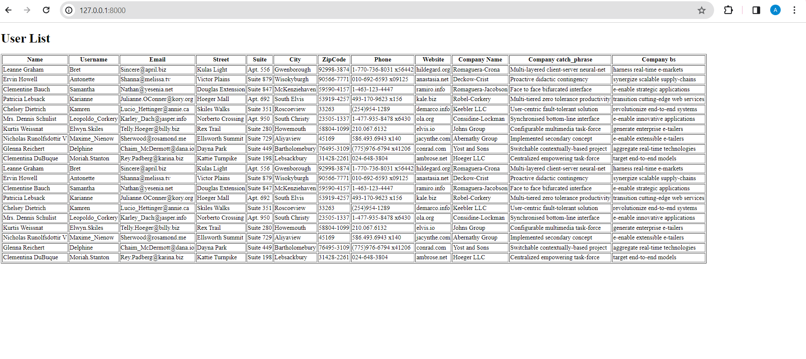

1. Steps for problem2:
   1. Downloaded djangorestframework
   2. Added it in the settings.py inside Installed_APPS
   3. Created serializers.py file to convert model instances into JSON_DATA
   4. Created a view to return the searilzed data
   5. Added the url path for the view
   6. And then ran the server to get the below data:

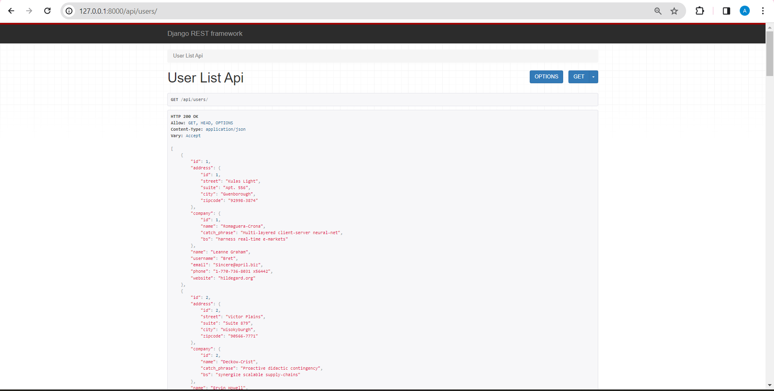

Solution Link: https://github.com/abanti-personal/django_interview.git